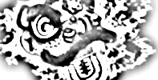
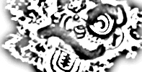
619 S. Trooper Rd • Audubon PA 19403 • 610-631-9200
Northern Shaolin Academy

10 Moving Chi Gong Exercises

1. Parting Wild Horses Mane (Repeat 3x)
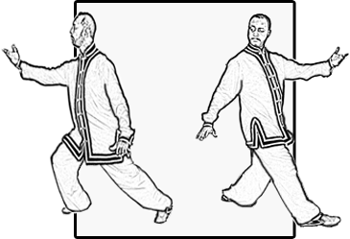
Bend your knees and position your hands at tigers’ mouth and press outward making a triangle as you step out at a 45° angle to the right with your right foot forward into a Kung Bu stance. Part the wild horses’ mane with right palm facing upward. Inhale and rotate to the right as you spread your hands, your left palm now turns up and your right comes back down along left side. Make sure you position your legs into a Sun -Ti Stance (60/40 stance) as you turn. Exhale and rotate your body and return to the starting point. Repeat.

2. Reach for the Sky (Repeat 3x Ea Side)
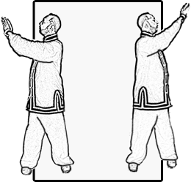
Step out to the right single shoulders width. Take a cleansing breath inhaling slowly as your palms come up to the solar plexus then turn your palms down exhaling slowly as they settle at waist level. Turn to the right both palms stay in the same position. Inhale slowly as you raise your hands straight upward with fingers extended reach for the sky and turn your body back to the left (180°). At this point relax wrists so palms form triangle with your palms facing downward. Exhaling slowly allow your hands to gradually come down as if “sliding down the pole”. Stop at waist level then turn 180° and repeat.

3. Splitting Palms (Repeat 3x Ea Side)

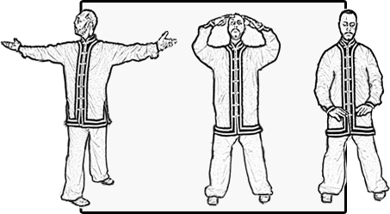
Step out to the right single shoulders width. Bend your knees and bring palms up to your solar plexus. Inhaling slowly begin to raise your body as you turn your waist to the right and split your left and right hands with both palms facing upward. Your left arm is towards the front wall and right arm towards the back wall. Raise your arms towards the ceiling fingers outstretched. Turn to face the front wall. Exhale slowly as you bring your arms down "slide down the pole" while your hand remain in a triangular position. Stop at your solar plexus. Turn your waist to the left and repeat the same actions.
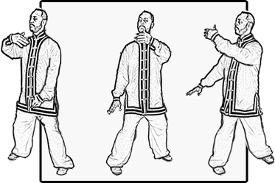
4. Low Waving Clouds (Repeat 3x)

Step out to the right single shoulders width while maintaining a medium height. Turn your body to the right as you wave your hands like clouds. Your right hand performs this action first while left hand lowers. Inhale slowly as right hand comes across front of body and exhale slowly as left hand comes across front of body.
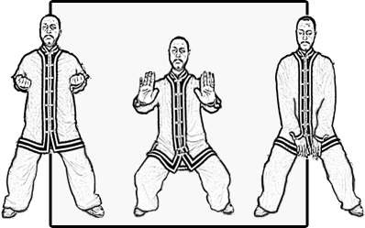
5. Lotus Flower Press (Repeat 3x)

Step out to a Ma Bu stance. Lower your arms and slowly inhale as your palms slide up the inside of your legs. Continue to raise your arms to arm pit level. Bring your elbows back and clench your fists. Exhale and open your palms like a flower and press forward as you sink down into a Ma Bu stance. Palms then drop down, as you sink down lower in your Ma Bu stance. Repeat this sequence.

Page 2 Cont,

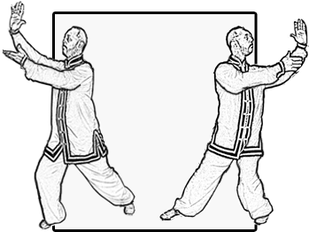
6. High Cloud Hands (Repeat 3x Ea Side)

Bend your knees and position your hands at tigers’ mouth and press outward making a triangle as you step out at a 45° angle to the right with your right foot forward into a Kung Bu stance. Position both hands so that your right fingers point upward and your left palm faces sky. Shift your stance from Kung Bu into Sun -Ti Stance (60-40 stance) while rotating arms in opposite directions performing cloud hands on the left. Left hand is high facing front wall while right palm lower and facing upward. Repeat.
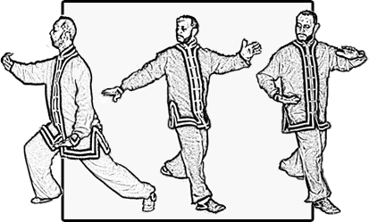
7. Ward-Off and Stirring the Pot (Repeat 3x Ea Side)

Bend your knees and position your hands at tigers’ mouth and press outward making a triangle as you step out at a 45° angle to the right with your right foot forward into a Kung Bu stance. Move your hands into a Ward – Off position. Turn your body to the right and simultaneously turn over right hand as rear left hand comes up as if to press on his shoulder. At this point you should be in a Sun -Ti Stance (60-40 stance). Your right hand then comes down and across your abdomen and back to Ward – Off while your left hand returns back to your left side. Repeat.

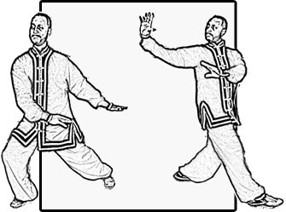
8. Figure 8 (Repeat 3x Ea Side)

Bend your knees and position your hands at tigers’ mouth and press outward making a triangle as you step out at a 45° angle to the right with your right foot forward into a Kung Bu stance. Hands actually look like they are tracing a figure 8. From right Kung Bu left and right arms shift and palms face down towards rear of left side. As you shift back right palm turns up as left is coming forward as if you were placing your palm on his shoulder and were to roll him over. Hands stop off right side towards rear (Ba Gua hands) both hands face rear wall. Your weight is now shifted into a Sun -Ti Stance (60-40 stance). Repeat
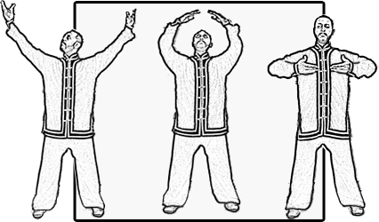
9. Gathering Focus (Repeat 3x)

Step out to the right single shoulders width. Bend your knees slightly and inhale very slowly as your arms extend and come up by your sides. Form a triangle overhead. Then “slide down the pole” exhaling slowly while lowering your body. Turn palms up and raise hands towards your solar plexus while inhaling then turn palms down while pressing downward and exhaling from Tan Tien.

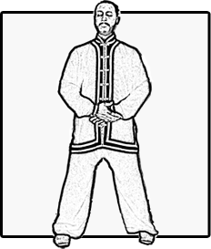
10. Following Breath (Repeat 3x)

Step out to the right single shoulders width. For Men place your left palm on your body with right palm on top at Tan Tien level. For women place your right hand close to your body with the left on top. Swallow saliva and have your mind follow the breath that chases it all the way down to the Tan Tien.

