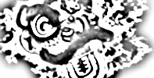
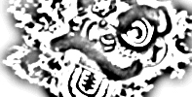
619 S. Trooper Rd • Audubon PA 19403 • 610-631-9200
Northern Shaolin Academy

18 Yang Style Tai Chi Fan Form

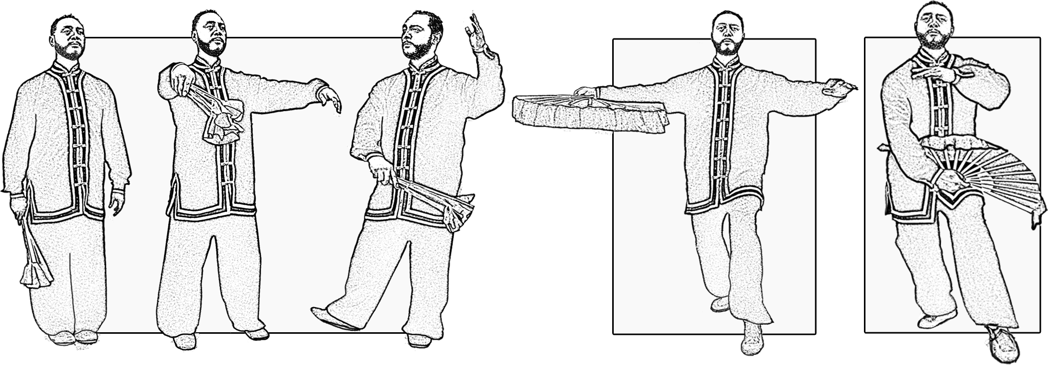

1 Open

2 Hold the Moon in Arms
High cat stance

3 Willow Waves in the Breeze
Holding the ball

1
2
3
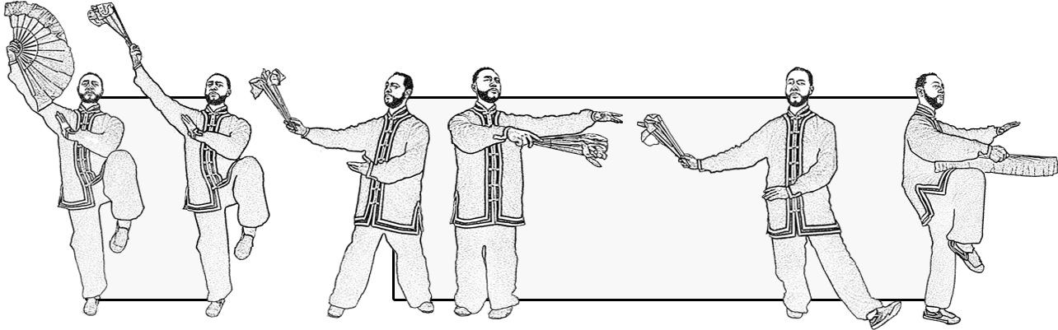

4 Dust Against
the Wind
Single stance

5 Waves Upon
Waves
Side stepping to
single leg stance
4
5

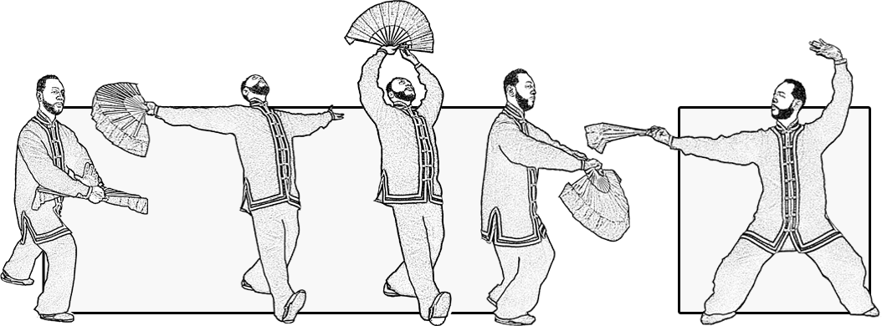

6 Old Man Angling
Leaning back hold fan up toe stance

7 Splitting in Horse Stance
Ma Bu with fan in hand

6
7
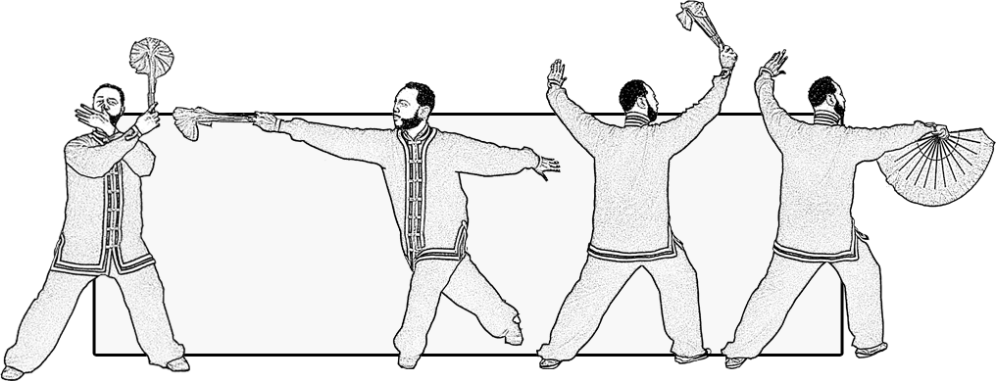

8 Turn Round and Strike the tiger
Turn & step behind/open fan

8

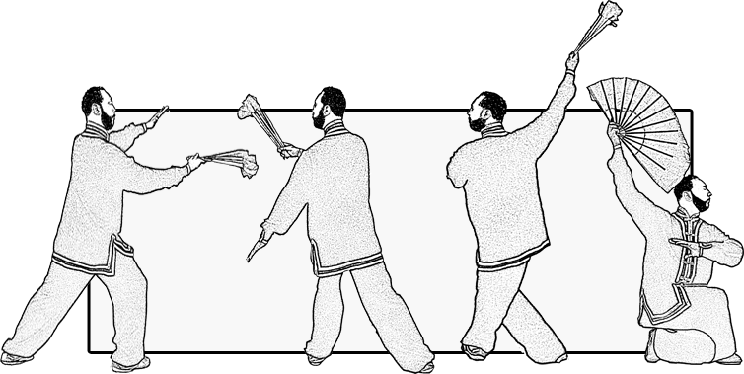
9 Holy Dragon Turns his Head
Drop down to sitting stance

9

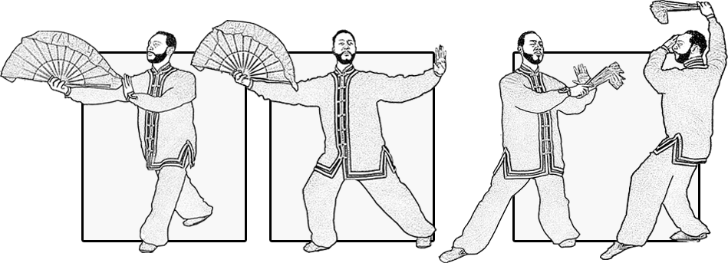

10 Open Fan Legs Apart
Gai Bu stance

11 Push the Boat Along with the
Current
Single whip

12 Pluck the Fan Both Sides
Raise the curtain - cat stance
10
11
12

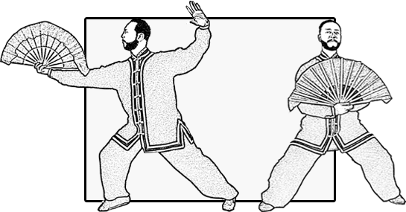
13 Holding the Fan While Riding Horse
Ma Bu stance

13

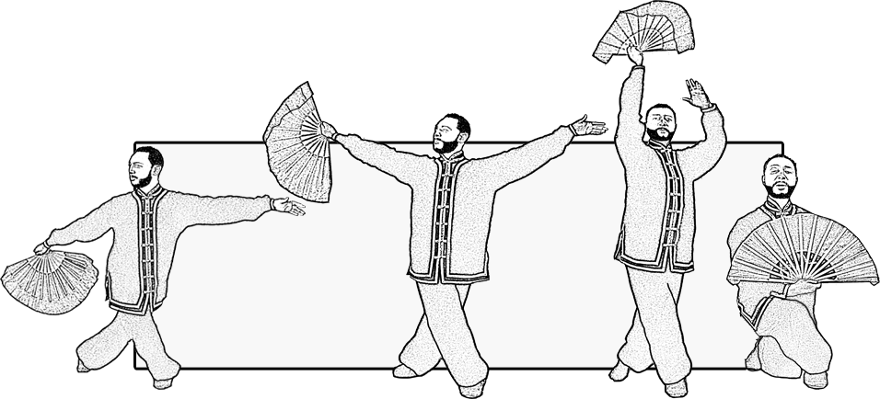

14 White Crane Spreads it's Wings
Step behind while raising fan

14

15 Wind Scatters the Lotus Leaves
Turn around into cat stance
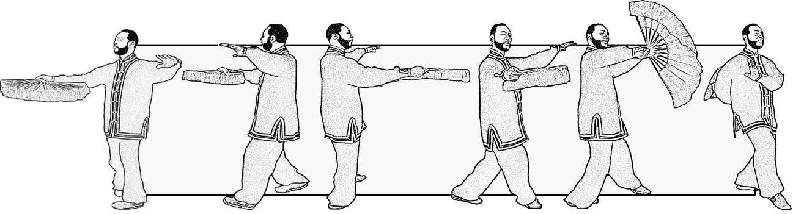

15

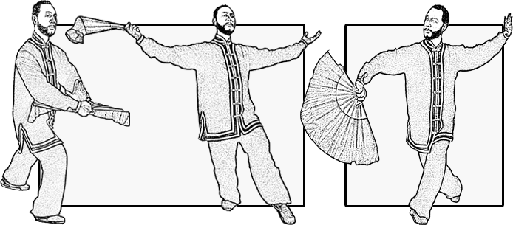

16 Spring Returns to the Land
Press and stand up & spread arms apart

17 Crossing Knees While Opening Fan
Scissors stance with fan

16
17

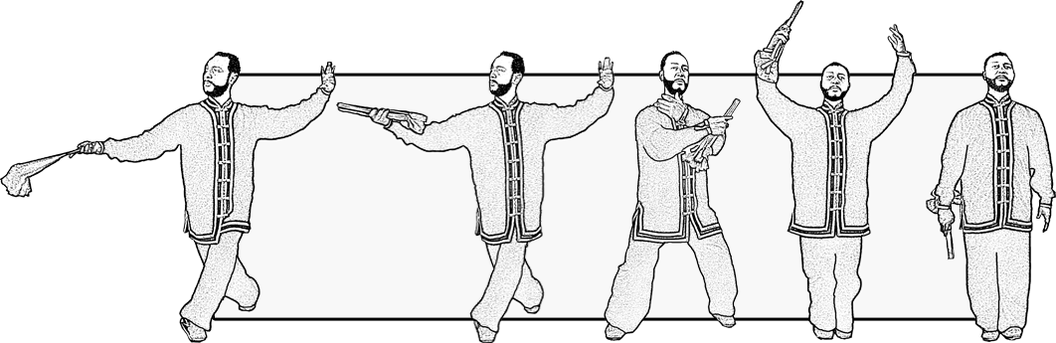

18 Close Form
18

