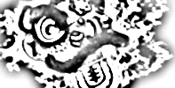
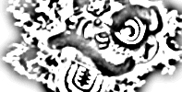
619 S. Trooper Rd • Audubon PA 19403 • 610-631-9200
Northern Shaolin Academy

Fighting Monk

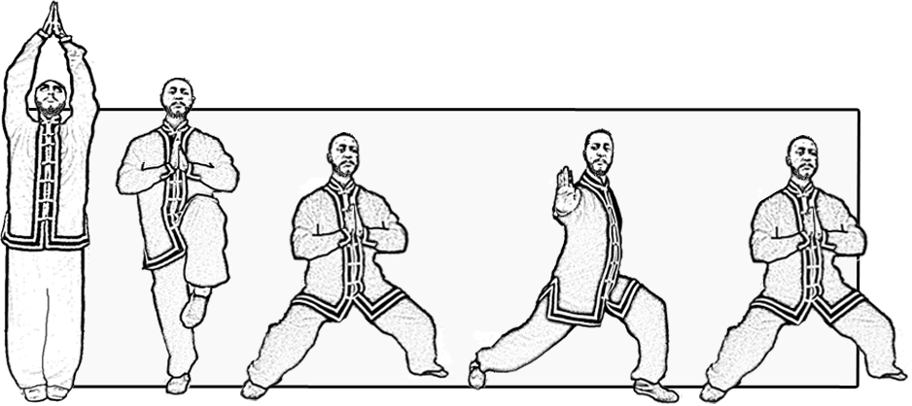
1. Standing Posture - Bing Bu
Raise Hands to Praying Hands at
Lohan Shou

2. Single Leg Stance - Du Li Bu

3. Horse Stance - Ma Bu Stance
Hands at Lohan Shou

4. Kung Bu Stance
Push out right palm - You Pan Chang

5. Horse Stance - Ma Bu Stance
Hands at Lohan Shou

6. Kung Bu Stance
Push out left palm - You Pan Chang
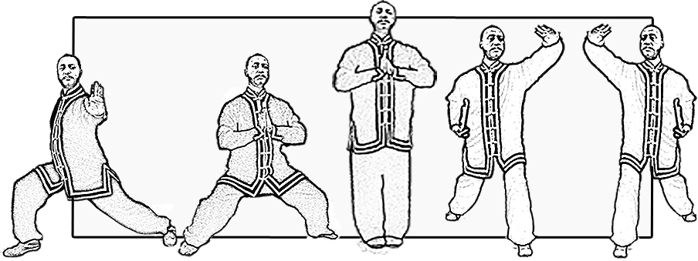
7. Horse Stance - Ma Bu Stance
Hands at Lohan Shou

8. Standing Posture - Bing Bu
Raise Hands to Praying Hands at
Lohan Shou

9. Kung Bu Stance – Zuo Pan Kung Bu
Left hand by head

10. Turn left to Kung Bu stance -
You Pan Kung Bu Right hand by head

11. Turn right to Standing Posture - Bing
Bu - Hands at Lohan Shou

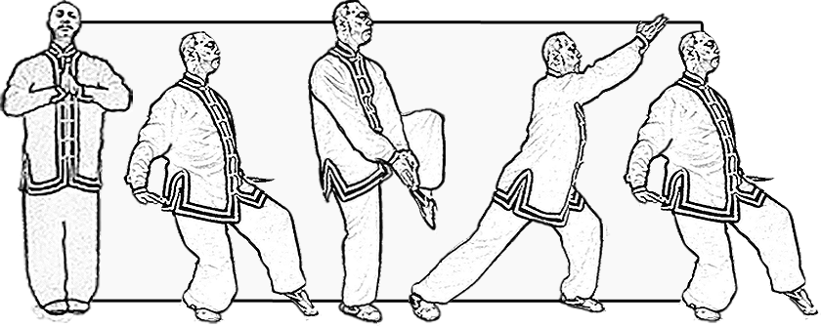
12. Step back to Cat stance- Shi Bu
Both palms back

13. Single Leg Stance - Du Li Bu
Palm together

14. Kung Bu Stance
Hands at Lohan Shou

15. Step back to Shi Bu
Both palms back

Page 2 Cont;

16. Single Leg Stance - Du Li Bu
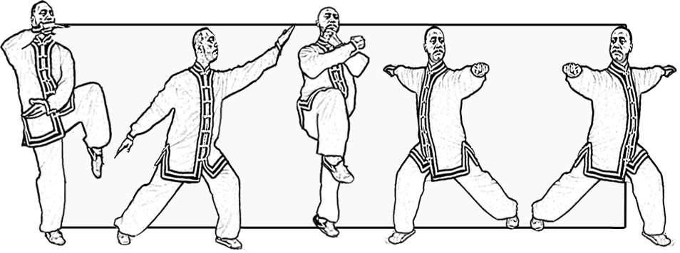
Crescent the ball

17. Slant Flying
Kung Bu stance - arms out

18. Single Leg Stance - Du Li Bu
Crossed fist

19. Kung Bu Stance
Right side – Hands at Lohan Shou

20. Kung Bu Stance
Left side- Hands at Lohan Shou

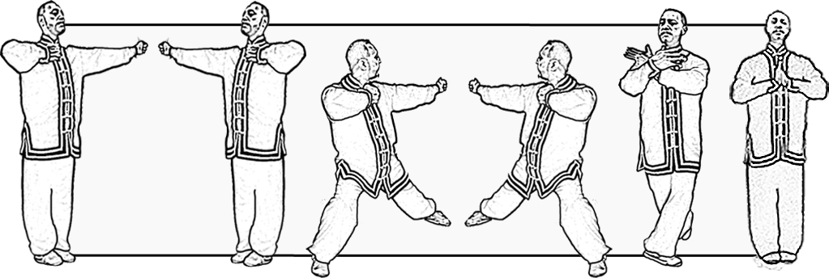
21. Standing Posture
Bing Bu - Left side Li Chuan

22. Standing Posture –
Bing Bu - Right Side Li Chuan

23. Taming Tiger Stance –
Fu Hu Bu - Strike back Fan Bei Da

24. Taming Tiger Stance –
Fu Hu Bu - Strike back Fan Bei Da

Close –Sou shi

